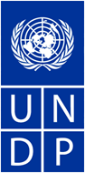
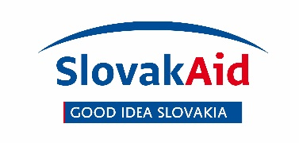 CALL FOR PROPOSAL

Slovak Transition Knowledge and Experience Transfer Programme for Moldova
Slovak Republic – UNDP Partnership for Results in the International Development Cooperation
Project title:
Strengthening fundamental rights protection: Support to National Center for Personal Data Protection

We invite Slovak non-governmental organizations (NGOs) and community-based organizations (CBOs) to apply and submit proposals for implementing the project “Strengthening fundamental rights protection: Support to National Center for Personal Data Protection”. Project is part of the ‘Slovak Republic – UNDP Partnership for Results in the International Development Cooperation’ programme, financially supported by the Ministry of Foreign and European Affairs of the Slovak Republic, through the Slovak Agency for International Development Cooperation. Programme is being implemented by the United Nations Development Programme.

Key information on the assignment

Micro-Capital Grant: Strengthening fundamental rights protection: Support to National Center for Personal Data Protection
Expected duration: 6 - 7 months (app. 72 work days in total)
Starting date: May 2016 End date: December 2017
Budget available: USD 87,000
Beneficiary country: Republic of Moldova
Local partners: UNDP Moldova, National Center for Personal Data Protection
Duty station: Home-based with travel to Chisinau, Moldova

Application deadline: 15 May 2017, 24:00 CET

Objective: to support the National Centre for Personal Data Protection (NCPDP) as a key player in personal data protection in the Republic of Moldova (RM) and the main beneficiary of the project’s interventions, and to further develop its capacities in ensuring the effective protection and promotion of personal data in the RM in compliance with the European standards. The support will especially go to the Legal and Public Relations Department and Evidence and Control department (NCPDP).

For more information see the Terms of Reference and for the information and documents to be submitted see the Application Template.

Proposals and related documents shall be submitted in English, by email to:

Ms. Henrieta Martonakova
UNDP – Slovakia Partnership Project Manager
United Nations Development Programme (UNDP)
Grosslingova 31, Bratislava, Slovak Republic
Email: henrieta.martonakova@undp.org

